NAME: Shriya Ramya Mohan ROLL NO: 241901106

EXERCISE 3
PASSIVE AND ACTIVE RECONNAISSANCE

AIM:
To do perform passive and active reconnaissance in TryHackMe platform.

ALGORITHM:
1. Access the Passive reconnaissance lab in TryHackMe platform using the link below-
https://tryhackme.com/r/room/passiverecon
2. Click Start AttackBox to run the instance of Kali Linux distribution.
3. Run whois command on the website tryhackme.com and gather information about it.
4. Find the IP address of tryhackme.com using nslookup and dig command.
5. Find out the subdomain of tryhackme.com using DNSDumpster command.
6. Run shodan.io to find out the details- IP address, Hosting Company, Geographical location
and Server type and version.

7. Access the Active reconnaissance lab in TryHackMe platform using the link below-
https://tryhackme.com/r/room/activerecon

8. Click Start AttackBox to run the instance of Kalilinux distribution.
9. Perform active reconnaissance using the commands, traceroute, ping and netcat.

OUTPUT:

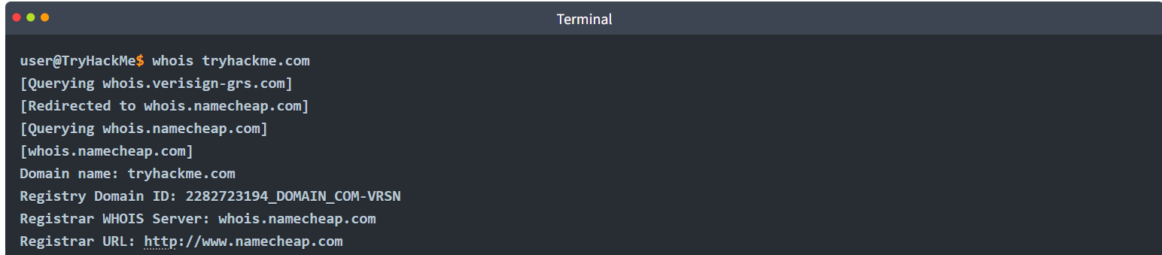

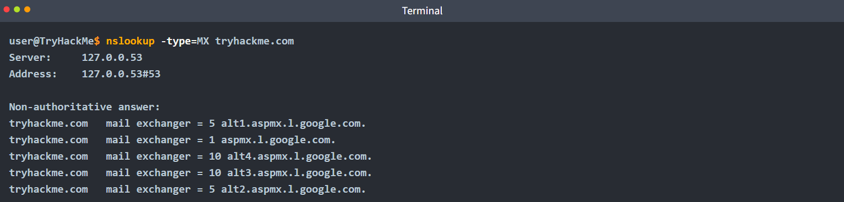

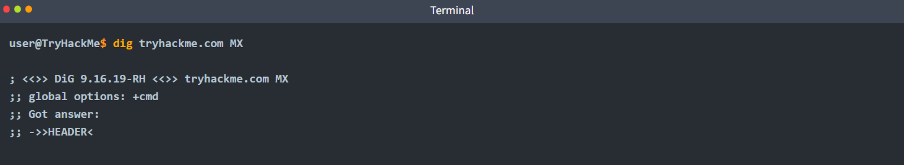

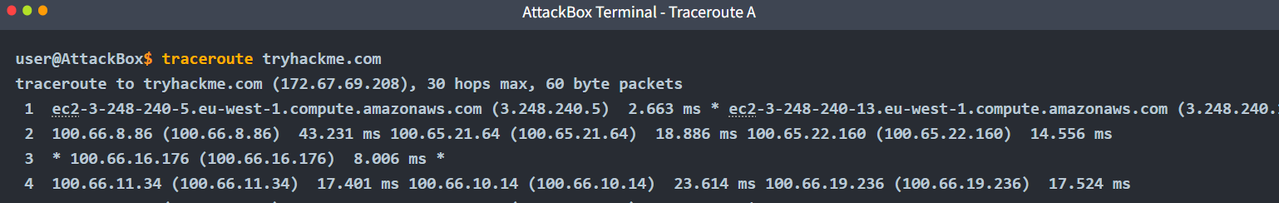

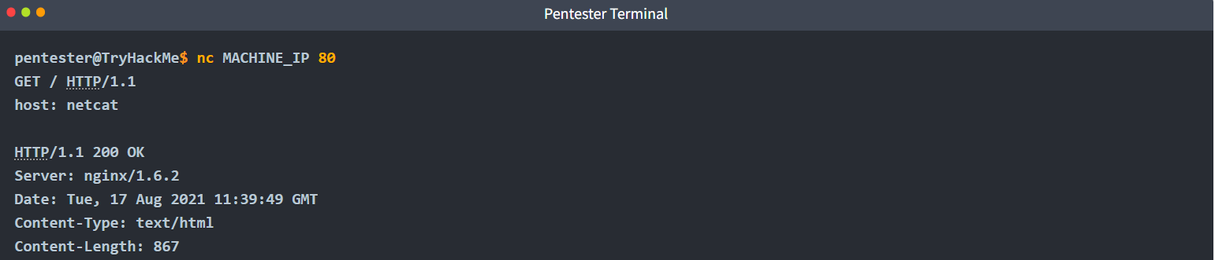

RESULT:
Thus, the passive and active reconnaissance has been performed successfully in TryHackMe platform.

